Case 5-Asia-China-Liangzhu-Tax Collector-Jade-3400–2250 BCE

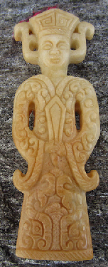 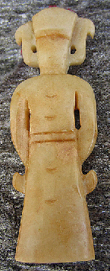 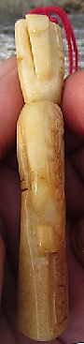

**Accession Number:**

**Formal Label:**

**Display Description:**

Liangzhu (3400–2250 BCE) in Yuhang County, Zhejiang, was a highly stratified Neolithic jade city-state in the Yangtze River delta where élites controlled a sphere of influence north to Shanxi and south to Guangdong. This tax collector exemplifies the mid Liangzhu period ca 3000-2800 BCE when jade and other expensive wares (such as silk, lacquerware, and ivory) characterized the social symbolism of Liangzhu élites which they used in ritual performances and dances as well as in grave goods.

**Case no.:**

**LC Classification:** NK5750.2.A1

**Date or Time Horizon:** Liangzhu culture, lower Yangzi River Valley, early Liangzhu Period, ca. 3200 BCE **Geographical Area:** Liangzhu culture, lower Yangzi River Valley

**Map:**

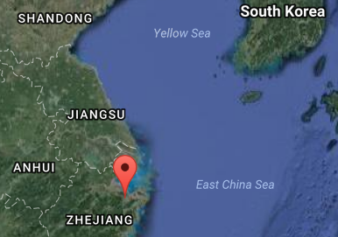

Fig. 4. Location of Liangzhu site proper.Source: Google Earth

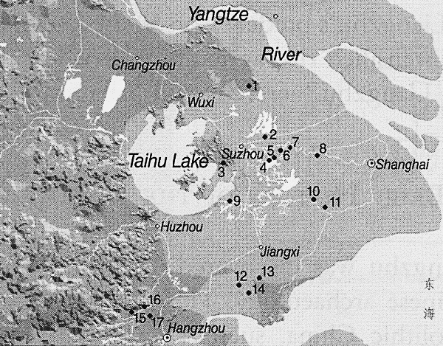

Fig. 5. Detail of Liangzhu site complex surrounding Taihu. After Zhou Ying 2007.

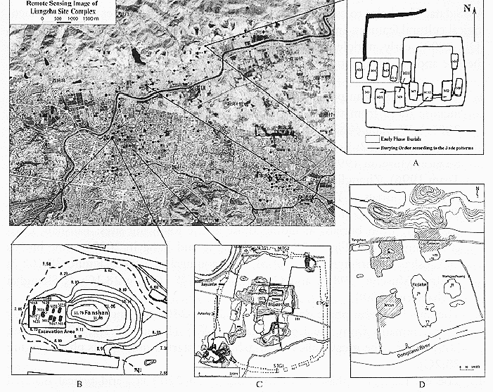

**Fig. 6.** Detail of Liangzhu site proper. After Zhou Ying 2007.

**GPS coordinates:**

Northeast corner: N 30°24'48", E 120°00'17"

Northwest corner: N 30°24'41", E 119°58'58"

Southeast corner: N 30°23'20", E 120 00'19"

Southwest corner: N 30°22'55", E 119°58'28"

**Cultural Affiliation:** Liangzhu culture, lower Yangzi River Valley, 3300-2250 BCE

**Medium:** Jade

**Weight:**

**Condition:**

**Provenance:**

**Discussion:**

**References:**

Biot, Jean Baptiste. 1851. *Le Tcheou-li: ou, Rites des Tcheou*. Paris: Imprimerie nationale, 1851. 3v.

Chang, K.C., Xu, P. and Lu, L. 2005. *The formation of Chinese civilization: an archaeological perspective*. New Haven: Yale University Press.

Childs-Johnson, Elizabeth. 1988. *Ritual and Power: Jades of Ancient China*. New York: China House Gallery, China Institute in America.

Childs-Johnson, Elizabeth. 2009. “The Art of working Jade and the rise of civilization in China.” In Elizabeth Childs-Johnson, *Early Chinese jades in American Museums.* Beijing: The Science Press, China Science and Technology Publishing and Media Co., Ltd., pp. 291-393.

Gu Fang. 2005. *Complete collection of unearthed jades in China*. 15 v. Beijing: China Science and Technology Publishing and Media Co., Ltd.

Hayashi, Minao. 林巳奈夫. 1991. *Chūgoku kogyoku no kenkyū*. 中國古玉の研究. Tōkyō: Yoshikawa Kōbunkan; 東京 : 吉川弘文館, 1991.



Hayashi, Mineo. 1990. “On the Chinese Neolithic jade Tsung/Cong,” *Artibus Asiae*, 50(1/2):5-22.

Hayashi, Mineo. 1973. *Toyo Gakuho* [Journal of the Research Dept. of the Toyo Bunko] 45:1-57.

Laufer, Berthold. 1912. *Jade a study in Chinese archaeology and religion*. Field Museum of Natural History, Publication 154, Anthroplogical series, vol. X. Chicago.

Li, Hui; Huang, Ying; Mustavich, Laura F.; Zhang, Fan; Tan, Jing-Ze; Wang, ling-E; Qian, Ji; Gao, Meng-He; Jin, Li. 2007. "Y chromosomes of prehistoric people along the Yangtze River," Human Genetics **122**: 383–388.

Lu Wenbao. 1998. Cong-shaped bead. In Liangzhu Culture Museum, ed., The dawn of Chinese civilization: Jades of the Liangzhu culture. Hong Kong: Liangzhu Culture Museum and The Art Museum, The Chinese University of Hong Kong.

Wu, Li. 2014. "Holocene environmental change and its impacts on human settlement in the Shanghai Area, East China," Catena **114**: 78–89.

Zhang, Chia; Hsiao-Chun, Hung. 2008. "The Neolithic of Southern China–Origin, Development, and Dispersal," Asian Perspectives **47**:2, 309–310.

|  |
| --- |
| Zhou Ying. 2007. 东方文明的曙光: 良渚遗址与良渚文化 = **Dong fang wen ming de shu guang: Liang zhu yi zhi yu liang zhu wen hua =** *The Dawn of the Oriental Civilization: Liangzhu site and Liangzhu culture*. Beijing: China Intercontinental Press. |